Practice TAsk 3 REPORT

« Operational amplifiers. Wien bridge oscillator»

**Principles of Circuits**

Student: CAO Xinyang 20321308

Program of Computer Science and Technology

Group CS

Name Surname

# Work purpose: to study parameters of Wien bridge oscillator

Goals:

1) Calculate parameters of Wien bridge oscillator

2) Compare calculated and simulated signal frequencies

# Starting data

* **Source voltage frequency, [Hz], $f_{test}= 8000$**
* **Load resistance, [Ω]: $R_{Load}=$**  1000000
* **Resistance *R*1 [Ω] [V]:**  15000
* **Voltage source power supply [V]: $V_{cc±}=$**  ±9

$V_{ref}=$ 1

# Calculations

* 1. Calculate

= 15000 []

* 1. Define (choose)

= 260000 []

* 1. Define (choose)

130000 [Ω]

* 1. Calculate C1 and C2 value in your model

$C_{1}=C_{2}=\frac{1}{2πR_{1}f_{test}}$ = 1326p [F]

* 1. Define *f*0 in Hz calculated from C1, C2, R1, R2 real values

[Hz]

* 1. Define *f*0 in from simulation results of Wien bridge with ideal operational amplifier

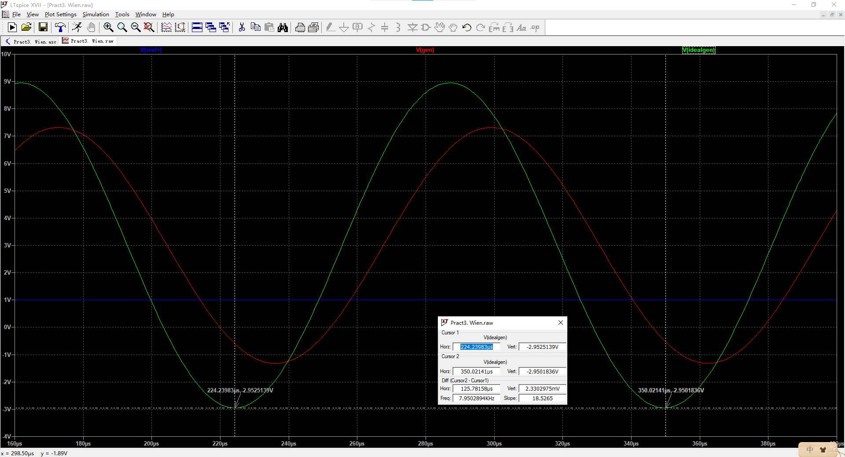

Figure 1. Results with ideal operational amplifier simulation

$f_{0_ideal}=$ 7950.29 [Hz]

* 1. Define *f*0 in from simulation results of Wien bridge with real operational amplifier

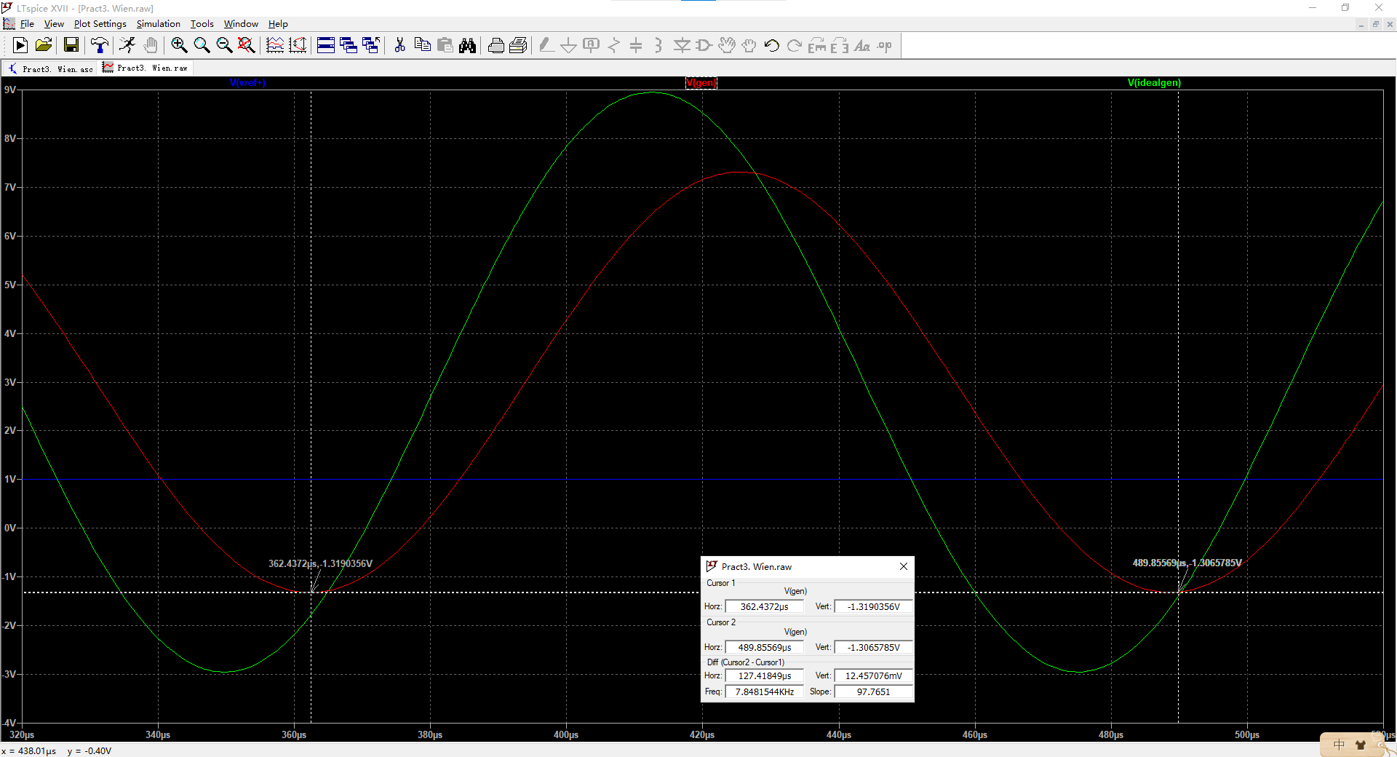

Figure 2. Results with real operational amplifier simulation

$f_{0_real}=$ 7848.15 [Hz]

# Conclusions

Conclusions should contain:

1. Values of $f_{0_real}$, $f_{0_ideal}$, $f_{0_calculated}$

$f_{0_calculated}=\frac{1}{2πR_{1}C_{1_real}}=$ $8000$ [Hz]

$f_{0_ideal}=$ 7950.29 [Hz]

$f_{0_real}=$ 7848.15 [Hz]

2) [Optional] Which resistor and capacitors correspond to the required parameters? Try to find a set of capacitor and resistors which could provide required frequency.